Robonality™

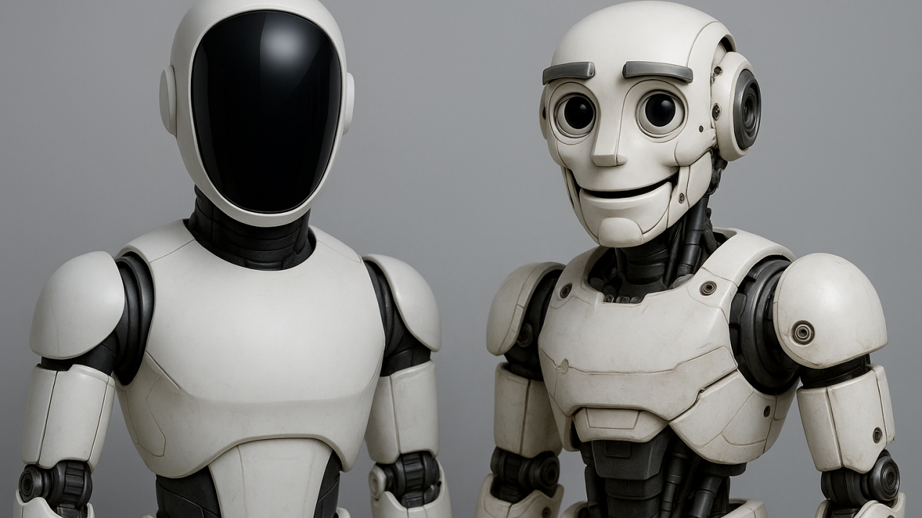
Humanizing the Future of Robotics
By Eric Allard
President at Allfx, Inc. | Leading Robotic Special Effects Supervisor
August 3, 2025

1. Executive Summary
For decades, robots have evolved in power, precision, and autonomy. Yet one critical element remains largely overlooked: emotional connection. Despite breakthroughs in artificial intelligence and mechanics, most robots remain cold, expressionless machines.
Robonality™ changes this. It is the science and art of giving robots personality — not just through AI but through design, motion, and expressive capability that allow them to feel “alive” to humans. By integrating Robonality™, robots become trusted companions, effective collaborators, and beloved characters rather than sterile tools.
This white paper introduces Robonality™ as a framework for the next generation of robotics — one that prioritizes emotional resonance as much as functionality. From healthcare to entertainment to consumer products, Robonality™ is the missing piece to unlock true human-robot harmony.

2. The Problem with Current Robotics
Today’s robots are extraordinary feats of engineering. Tesla’s Optimus, Figure AI’s humanoid prototypes, and Boston Dynamics’ Atlas demonstrate impressive locomotion, dexterity, and intelligence. Yet their designs share one fundamental flaw: they are emotionally blank.
- Their faces are featureless or inert.
- Their gestures lack nuance or empathy.
- Their interactions feel transactional rather than relational.
This lack of emotional design creates an invisible barrier to adoption. Humans instinctively relate to beings that mirror their emotional world. When robots fail to offer this, they remain objects of fascination rather than partners in daily life.
The solution is not merely programming better AI responses — it is engineering expressive physical and behavioral design that engages humans at a primal, empathetic level. This is the foundation of Robonality™.

3. What is Robonality™?
Robonality™ is a holistic design philosophy that fuses robotics, psychology, and character-driven thinking to create emotionally expressive machines.
Definition:
Robonality™ is the deliberate application of mechanical, visual, and behavioral design to imbue robots with a personality that humans can instinctively understand, relate to, and trust.
Key components include:
- Expressive Movement: Subtle gestures like head tilts, “micro-shrugs,” or the way a robot shifts its posture when listening.
- Facial Expressiveness: Mechanically driven features — eyelid movements, eyebrow actuators, and lens adjustments — that create recognizable emotional states.
- Vocal & Timing Cues: The cadence, pauses, and inflections in speech that make a robot sound approachable and attentive.
- Interaction Feedback Loop: A closed system where robots visually and behaviorally react to human actions in real time.
Robonality™ doesn’t make robots “pretend humans.” Instead, it defines a language of emotional signals that is non-threatening, endearing, and mechanically grounded.

4. The Science of Emotional Robotics
Humans are biologically wired for empathy. Mirror neurons in our brains respond to observed behaviors, even when performed by non-human entities. This is why we feel tension watching an animated character struggle or why a mechanical robot with simple “eyebrow” movements can appear thoughtful.
Robonality™ leverages this psychological mechanism:
- Micro-movements create perceived intent.
- Expressive mechanics trigger empathy.
- Consistent personality traits build trust.
By aligning robotics design with cognitive psychology, Robonality™ transforms machines from tools into characters that engage us on a human level.

5. Case Study: Johnny 5 – Proof of Concept
In 1986, Short Circuit introduced Johnny 5 — a robot whose design broke new ground in emotional expressiveness. Unlike featureless machines of the era, Johnny 5 had:
- Articulated “eyebrows” that allowed for nuanced emotional states.
- A kinetic head and neck that simulated attention and curiosity.
- A vocal delivery paired with mechanical “acting.”
These design choices created something unprecedented: a robot audience didn’t just watch — they rooted for, laughed with, and even cried over. Four decades later, Johnny 5 remains iconic because he proved that expressive robotics could transcend novelty and connect emotionally with millions.
Robonality™ formalizes this approach, transforming what was once a cinematic breakthrough into a repeatable design standard for real-world robotics.

6. The Current Industry Landscape
Modern robotics companies are solving incredible technical problems — but emotional design remains largely absent.
- Tesla Optimus and Figure AI focus on physical capability but lack visual or behavioral cues for trust.
- Boston Dynamics showcases movement mastery, but its robots remain characterless.
- Social robots like Jibo or Pepper attempted friendliness but failed due to shallow emotional design and limited adaptability.
Robonality™ bridges these gaps by introducing a scalable framework for expressive design, making emotional connection a core feature rather than an afterthought.

7. The Robonality™ Framework
Robonality™ is structured in progressive levels that can be implemented across industries:
- Foundational Robonality™ – Basic empathy cues (head tilts, subtle postural shifts).
- Expressive Robonality™ – Mechanically driven facial and gesture-based emotional range.).
- Signature Robonality™ – Branded personalities unique to specific robots or companies, creating market differentiation. This layered approach ensures robots evolve from functional to emotionally fluent without overwhelming technical complexity.

8. Applications Across Industries
Robonality™ is not just for consumer-facing robotics — it applies across multiple sectors:
- Healthcare: Expressive robots reduce anxiety for patients, especially children and the elderly.
- Education: Robots with personality increase engagement and retention in learning environments.
- Hospitality & Service: Friendly, expressive robots build trust with customers and improve brand experience.
- Entertainment & Media: Personality-driven robots become franchises, mascots, and stars.
- Home Robotics: Robonality™ transforms household machines into companions people enjoy interacting with.

9. Implementation Roadmap
To accelerate adoption, Robonality™ will introduce:
- The Robonality™ Seal of Approval: Certification for robots that meet specific expressiveness standards.
- Design Guidelines: Clear principles for mechanical expressiveness and personality-driven behavior.
- Pilot Programs: Partnering with robotics manufacturers to implement Robonality™ in early-stage prototypes.
- Software & Hardware Toolkits: Modular solutions for integrating expressive mechanisms without prohibitive cost.

10. Conclusion
The future of robotics isn’t just functional — it’s emotional.
Robonality™ represents a paradigm shift in design thinking: a move away from sterile machines and toward relatable, trustworthy, and even lovable companions. By bridging the emotional gap between humans and robots, Robonality™ will define the next great leap in robotics innovation.
The choice is clear: build machines we use… or create robots we welcome.
Human-to-Robot Expressive Interface: The Language of Faces
Humans are hardwired to communicate through facial expressions. Before we learn to speak, we recognize a smile, a frown, or a raised eyebrow. These micro-expressions are a universal language, transcending culture and words. In designing emotionally resonant robots, we must first respect this primal, human code.
From Human Faces to Robot Faces


The image above demonstrates a range of genuine human emotions—joy, surprise, anger, curiosity, fear, and delight. These expressions form the foundation of trust and connection in every social interaction.
If robots are to coexist naturally with us in homes, workplaces, and entertainment, they must be able to mirror, interpret, and respond to these same emotional cues.
Robotic Expression as a Bridge
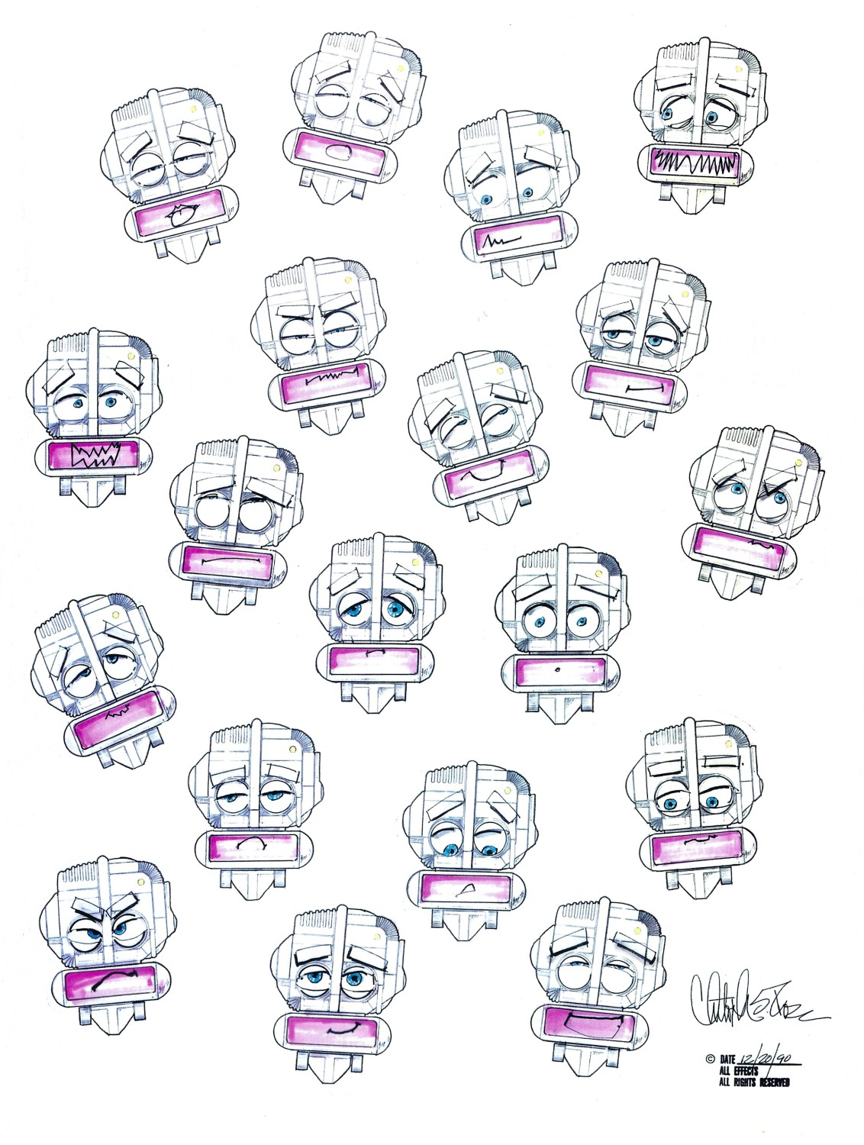
Robonality™️Get Some
This is Robonality™ in action: the seamless adaptation of human emotional language into robotic form. Miles Robot facial expressions art Each variant is deliberately simplified yet evocative, proving that even mechanical forms—eyebrows made of segmented panels, eyes as lenses, and mouths as LED displays—can carry unmistakable emotional weight.

